

**International Circle**

Project plan

Version 1.2

**Authors:**

Mihael Druzeta

Diego Duchini

Do Khoi Nguyen

Artem Shnyrov

Leon Tracey

Mihaela Covali

Erika Nicolau

**Student number:**

5367131

5280125

5275415

5398290

5367697

5292891

5326745

**Client:**

Jan Doornbos

**Date:**

09/15/2023

|  |  |  |
| --- | --- | --- |
| Version | Date | Description |
| 1.0 | 13/9/2023 | Initial draft of the document |
| 1.1 | 27/9/2023 | Adjustments to the document |
| 1.2 | 06/10/2023 | Improving clarity on some chapters |

**Version Control**

**Table of Contents**

Version Control ........................................................................................................ 2

Chapter 1: Introduction ............................................................................................ 4

Chapter 2: Project Result.......................................................................................... 5

Chapter 3: Project Activities..................................................................................... 6

Chapter 4: Project Limits.......................................................................................... 8

Chapter 5: Intermediate Results .............................................................................. 9

Chapter 6: Quality Control ..................................................................................... 10

Chapter 7: The project organization….................................................................... 11

Chapter 8: Planning & Scheduling ......................................................................... 14

Chapter 9: Costs & Benefits …............................................................................... 15

Chapter 10: Weekly Timesheet ............................................................................... 16

Chapter 11: Risk Analysis ...................................................................................... 17

**Chapter 1: Introduction**

Circle solutions™ is an (inter)national software development agency that develops customized software. Circle solutions™ has recently started working for international clients. Circle solutions™ optimizes business processes with manufacturing software. They complete the circle; and realize that this circle is unique for every company. As intuitive as a visit to each other’s office; this is how the software of circle solutions connects where necessary.

Circle solutions™ wants a new website that offers general information about the services they provide, with a focus on acquiring international customers. The internal stakeholders of this project are Jan Doornbos as a project manager along with Team IT1C as the web developers. Circle Solutions™, who is interested in delivering a high-quality commercial product, IT1C is interested in assisting Circle Solutions™ in development of software in exchange for valuable working experience.

It is up to the project group to include this objective in the design process and final product realization (website). Working with the founder will help the group learn the basic of developing a website in HTML5/CSS3, which are crucial skills in the future collaborations of the group. Future users of Circle Solutions™ website are the main stakeholders, as the website would allow them to purchase the products of Circle Solutions™ related to Internet.

External stakeholders of the project would include future cyberspace related associates as better collaborations would benefit the whole Circle Solutions™ company, earning more revenue and earn more supporters in future developments.

The main objective of this collaboration is to provide Circle Solutions™ with a website that provides the company the ability of selling their cyberspace products. Using HTML5/CSS3, IT1C will design and program the website and incorporate features requested by the client itself are as it follows:

1. Promoting and selling products (Intranet)
2. Sign up form for their news letter
3. Language option (English & Spanish)

**Chapter 2: Project Results**

This chapter describes the time constraints and conditions of the project to meet the expectations and deliverables for Circle Solutions.

**Specific:**

The project aims to create a website to open Circle Solutions™ to international customers to make their brand worldwide.

Our project called “International Circle” aims to allow customers from all over the world to have access to all that Circle Solutions™ has to offer.

**Measurable:**

* Client is expected to provide the team with feedback about the product on a regular basis.
* Client is expected to collaborate with the team on a regular basis during the work week.
* The group estimates that the company will increase the international clients percentage of at least 10%

**Achievable:**

The documentation for this project will require us to research outside the learning boundaries of this course and to develop more skills meant to create the best functionalities of the product.

**Reliable:**

We plan on doing this by implementing the most nation-wide languages and making the project visually accessible to the customers, meaning if they don’t understand the language they can still understand what the website entails only from the design.

**Time-line:**

The project will operate within a framework of 9 weeks, starting on the 4th of September 2023 and concluding on the 12th of November 2023.

**Chapter 3: Project Activities**

This chapter describes in detail the activities which are to be completed for a project to be successful. Therefore, those details are included in the diagram from the Chapter 8 more summarized.

**Design Phase:**

**1.Interview**

* Conducting client meetings
* Recording and analyzing the information received
* Gathering the data from the company

**2.Project Plan:**

* Developing a project plan within the framework of 9 weeks
* Allocating the assignments for each member

**3.Creating the design (first iteration)**

* Designing seven individual prototypes
* Receiving feedback according to UI (user interface) and UX (user experience)

**4.Handing in the second iteration**

* Presenting the updated design with all the required functionalities

**5.Improving the design**

* Checking the website’s information architecture

**6.Testing**

* Conducting an usability test of the final design

**7.Results**

* Approving the final design by the client

**Implementation phase:**

**7.Realization of the website**

* Choosing the technology stack ( HTML, CSS, PHP etc.)
* Developing the website’s back-end and front-end
* Implementing features and functionality

**8.Delivering**

* Involve stakeholders in testing the website
* Address any issues and feedback
* Ensure the website meets client expectations

**Presentation phase:**

**9.Presentation:**

* Conducting a project review and evaluation
* Complete and present the final product to the audience

**Chapter 4: Project Limits**

This chapter describes the time boundaries of the project and conditions that must be fulfilled for it to be successful.

* The project starts on the *6th of September 2023*.
* The estimated deadline for the final product is on *5th of November*.
* All documentation and presentation are on the *6th – 10th of November*.

**Boundaries:**

Here the project's boundaries will be briefly discussed for all parts:

* The website will be developed only by the team IT1C.
* All used research and resources must be given by the client himself through Microsoft Outlook.
* The Supervisors are allowed to review the project any time at their convenience.
* The result of the project is going to be a website with his own local database and not connected through Cloud.

**Success Requirements:**

For the project to be successful, it is necessary for this group to:

* To be able to reach contact with the client at least twice per week and one time with the supervisor.
* To have weekly discussion with the client to see if the output matches the client’s expectations.
* All project activities from chapter 3 must be carried out in a timely manner.

# The project requirements as agreed upon in the Project Plan document is fulfilled.

**Chapter 5: Intermediate Results**

* **Plan of approach (Project Plan)** **–** a document, which explains the project work organization.

**Deadline: 15 (fifteen) September 2023 (two thousand twenty-three)**

* **Design Documents (1)** **–** the first design of the web page

**Deadline: 15 (fifteen) September 2023 (two thousand twenty-three)**

* **Design Testing** **–** the process of checking designs in terms of requirements and content.

**Deadline: 22 (twenty-two) September 2023 (two thousand twenty-three)**

* **Design Documents (2) –** the second design of the web page

**Deadline: 22 (twenty-two) September 2023 (two thousand twenty-three)**

* **Usability test** **–** a document that summarizes the evaluation of the website by testing it with representative users.

**Deadline: 6 (six) October 2023 (two thousand twenty-three)**

* **Design Documents (final)** **–** the final design of the web page

**Deadline: 6 (six) October 2023 (two thousand twenty-three)**

* **Technical Design –** a document that summarizes how the final product works from a technical standpoint.

**Deadline: 3 (three) November 2023 (two thousand twenty-three)**

* **Final Product –** the final product will be handed in, including a detailed explanation, with all the available documentation.

**Deadline: 6 (six) November 2023 (two thousand twenty-three)**

**Chapter 6: Quality Control**

To ensure the highest quality of our project, the following conditions must be carried out:

* The project design will be developed on Figma by every group member individually to ensure to include all group member’s ideas and contributions.
* After the final decision of the design, IT1C will be begin developing the website in Microsoft Visual Studio Code using HTML5 and CSS3 as the coding language.
* IT1C will be in contact with the client to ensure our design is up to standard and approved by the client himself.
* IT1C will use a timesheet to track everyone’s work and ensure everyone is doing their share of work to the highest standard.

The quality of our project is assured as follows:

IT1C will do regular tests to ensure our project is running smoothly and consistently, the testing will be done in 3 steps:

* Unit testing
* Integration Testing
* System Testing

All work done by each group member will be reviewed and based on the feedback by the rest of the group, it will be implemented to the final design to ensure the highest quality. Our product has been delivered in phases to ensure each part has been worked on sufficiently and is up to the group standards.

In this project, the team will be using the methodology of Roel Grid’s Project Management Version 5(Roel Grid, (2022). Project Management. A Practical Approach. Groningen, Netherlands: Noordhoff Uitgevers.

**Chapter 7: The project organization**

The team consists of the following members:

**1. Diego Duchini (ProjectLeader)**

The role of a Project Leader is to guide and lead the rest of the team to a better outcome and to a more successful result of the project, by explaining the details of every task that needs to be achieved and giving them feedback on their results to improve.

**Email**: [diego.duchini@student.nhlstenden.com](mailto:diego.duchini@student.nhlstenden.com)

**Phone number**: +39 3923698417

**2. Erika Nicolau (Secretary)**

The purpose of the secretary is to have notes on every single important detail when we are gathering information in meetings with the clients or in team meetings which will guide us on what task needs to be done, also she will help the Leader with managing the tasks distribution, in addition she’ll take the role of the team leader when the leader is not available.

**Email**: [erika.nicolau@student.nhlstenden.com](mailto:erika.nicolau@student.nhlstenden.com)

**Phone number**: +40 728 243 107

**3. Mihael Druzeta(Innovator)**

The innovator is always a steady stream of new ideas. The innovator will help a lot in environments where new and fresh ideas or concepts are regularly needed such as product development, branding and design or envisioning the key activities of a project plan.

**Email**: [mihael.druzeta@student.nhlstenden.com](mailto:mihael.druzeta@student.nhlstenden.com)

**Phone number**: +385 91 300 2999

4. **Mihaela Covali (Completer Finisher)**

The Complete Finisher is concerned with deadlines and will push the team to make sure that the job is completed on time. As a perfectionists that’s conscientious and anxious about the final product she will be crucial on the last review before moving on with the next path of the project.

**Email:** mihaela.covali@student.nhlstenden.com

**Phone number**: +373 608 09 746

**5. Do “Bill” Koi Nguyen (Resource investigator)**

He will explore available options, develop contacts, and negotiate for resources on behalf of the team. He’s the one who identifies and works with external resources to help the team accomplish its objective.

**Email**: do.do@student.nhlstenden.com

**Phone number**: +316 44 243 982

**6. Leon Tracey (Client Communicator)**

He will shape internal comunication to give team members a better understanding of their purpose; of course he’ll be the one in charge of the consultation with the client. Helping leaders communicate also means becoming a coach for them.

**Email**: leon.tracey@student.nhlstenden.com

**Phone number**: +353 85 713 7300

**7. Artem Shnyrov (Facilities Manager)**

He’s responsible for the maintenance and upkeep of the technical devices or rooms buildings. He’ll also operate across different functions, working on both a strategic and operational level.

**Email**: artem.shnyrov@student.nhlstenden.com

**Phone number**: +31 6 13418545

**Daily Availability**

|  |  |  |  |  |  |  |  |
| --- | --- | --- | --- | --- | --- | --- | --- |
| **Name:** | **Monday** | **Tuesday** | **Wednesday** | **Thursday** | **Friday** | **Saturday** | **Sunday** |
| **Diego** |  |  |  |  |  | - | - |
| **Erika** |  |  |  |  |  | - | - |
| **Mihael** |  |  |  |  |  | - | - |
| **Mihaela** |  |  |  |  |  | - | - |
| **Bill** |  |  |  |  |  | - | - |
| **Leon** |  |  |  |  |  | - | - |
| **Artem** |  |  |  |  |  | - | - |

**Chapter 8: Planning & Scheduling**

* This chapter illustrates the main steps in the project planning process via a diagram,

meant to show the exact details about the time-line, the phases which are going to be followed by the team and the meetings with the client.

* The chart is based off the third chapter of this document, project activities.
* The project is expected to cost 280 man-hours per person or 1960 hours in total among

all seven team members. Each team member is expected to work around 31 hours per week.

* The planning has been discussed with all of the team members and the assignments for

every part of the plan has been shared according to the team roles.

* If there are going to be some delayed decision-making, the team is going to respond as

soon as possible with a solution, without changing the time-line of the project plan and communicate with their client every problem that appears.

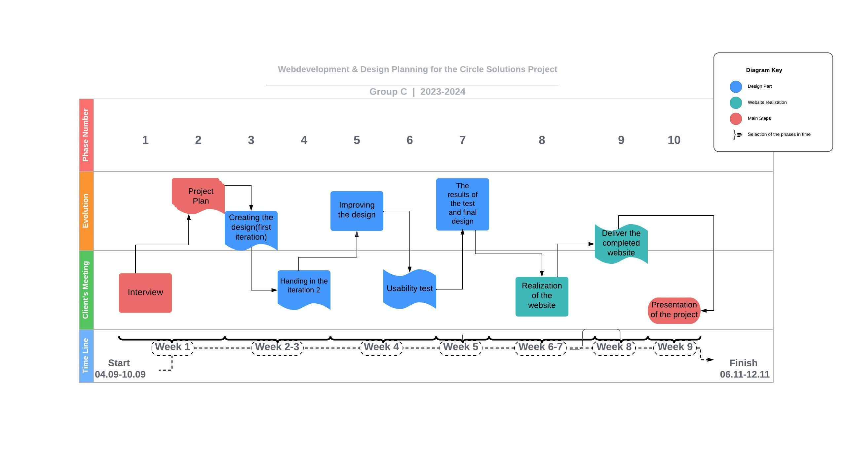

**Chapter 9: Costs & Benefits**

In this chapter, it is important to emphasize that the project will operate on the client’s budget of €5.000.

**Benefits**

Once the website is in a completed state, the client will accrue several substantial benefits, those many benefits are for instance:

1. Brand building: One of the many benefits that the founders will gain is to showcase their company identity to the other companies, gaining more customers, revenue, and the possibility of collaborating with other companies, boosting up their market reputation.
2. Marketing and Promotions: The founders will be able to use marketing strategies, such as newsletters, market emails and engage their target audience.
3. Flexibility: The founders will have full control over the website’s content, design, and functionality. Giving them adaptability and evolving goals for the company.
4. Long-Term Asset: The website will be a long-term asset. It will continue to generate revenue for the company and benefit for years to come.

**Chapter 10: Weekly Timesheet and Meetings**

This chapter shows the weekly timesheet of each member of IC1T and the weekly meetings with the client.

**Weekly Timesheet:**

|  |  |  |
| --- | --- | --- |
| **Name** | **Action Points** | **Deadline** |
| Diego Duchini | Home page | 13/10/2023 |
| Erika Nicolau | News page | 13/10/2023 |
| Mihael Druzeta | About me | 13/10/2023 |
| Mihaela Covali | Read more page | 13/10/2023 |
| Do “Bill” Koi Nguyen | Product page | 13/10/2023 |
| Leon Tracey | Sign up and Contact Page | 13/10/2023 |
| Artem Shnyrov | Service page | 13/10/2023 |

**Weekly meetings:**

|  |  |  |  |
| --- | --- | --- | --- |
| **Time** | **Date** | **Place** | **Minutes of meeting** |

**Chapter 11**

This chapter analysis the expected risks over the course of this project. These risks will be measured over a 1 (lowest) to 5 (highest) scale.

|  |  |  |
| --- | --- | --- |
| **Overview of Risks taking place** | | |
| **Risks** | **Scale** | **Viable solutions** |
| If the website faces a software problem | 4 | Send a message to customer support through the application about software problem and an IT student will fix it. |
| Probability of group member getting sick | 2 | The member will Inform the team and the team will adapt on to this unpredicted event. |
| Probability of a group member getting kicked out of the group. | 3 | The member will be kicked out of the group and the team will have to adapt to this decision. |
| Probability of losing essential data | 2 | Send a message to customer support through the application about website problem and an IT student will fix it. |